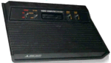
The Atari 2600 was one of the most popular home consoles ever produced and was first released in 1978.
Specs:
- CPU: 6507, 1.19 MHz
- Memory: RAM - 128 Bytes in VLSI, ROM - 4K max
- Graphics: A custom chip named Stella and a graphics clock that run at 1.19 MHz
- Storage Method: Carts
- Input: 2 Joystick ports

